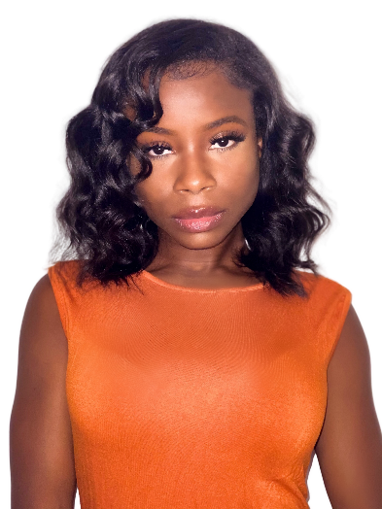 **Jae Coutrier**

[**jcoutrier@gmail.com**](mailto:jcoutrier@gmail.com)

(954) 559-3733

**www.jaecoutrier.com**

Height: 5’0

Weight: 110 lbs.

Voice: Alto/Soprano 2

**FILM**

Escape Pod Lead Torchlight Productions

Republic of Lydia Principle Torchlight Productions

Baphomet High Principle Torchlight Productions

Sight Principle Torchlight Productions

**THEATRE**

Rosencrantz and Guildenstern Are Dead Ophelia The Lab Theatre

Cloud 9 Mrs. Saunders/Soldier The Lab Theatre

Hansel and Gretel The Sandman Actors Playhouse

Bourbon at the Border May Louise O. Gerrits Theater

A Chorus Line Diana Morales Actors Playhouse

Stuart Little Margalot Actors Playhouse

**TRAINING**

**Florida State University Bachelor of Fine Arts (BFA) in Acting- Tallahassee, FL**

Acting: Michael Hayden, Jean McDaniel Lickson, Fred Chapell, Leslie France

Patterson, Lori Singer

Voice & Dialects: Debra Hale

Movement: Kate Gelabert

**New World School of the Arts (Musical Theatre)- Miami, FL**

Musical Theatre/Acting: Gail Garrisan, Ron Headrick, Stuart Meltzer, Ethan

Henry, Jeff Hess, James Randolph, David Qwait,

**London Theatre Academy- London, England**

Acting: Mick Barnfather

Stage Combat: Rachel Bown-Williams, Bethan Clarke, Ruth Cooper-Brown

**SPECIAL SKILLS**

BADC Stage Combat certified with distinction (rapier, dagger, unarmed combat), Voice: Southern, British, Cockney and African dialects, Singing, Writing

**HONORS**- YoungArts Winner, Best Actress Short Film (Florida Horror Film Festival)